**________________________________________________________________________**

**Navigating Dropbox**

1. **Each Partner has a** [**dropbox**](http://www.dropbox.com) **folder**

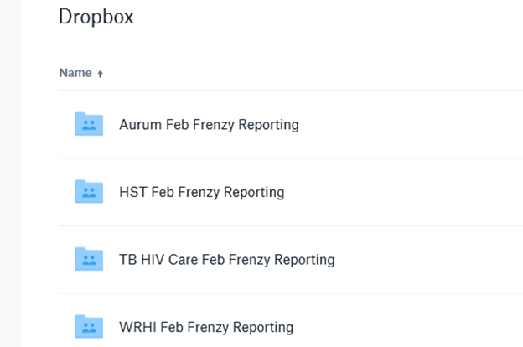

1. **Each folder includes the following documents:**

* ***1. Partner Siyenza Due Dates***
* ***2. Reporting Tool_FINALIZED***
  + See ‘ Downloading *‘Reporting Tool_FINALIZED’ tools from dropbox* section below
* ***3. Service Designation Hours and Facilities Affected***
  + Download Every Monday after 12pm, and save here (replace current file)
    - *S:\ESI\_DASHBOARDS DATA GUIDANCE_\DATA_SIYENZA\Service Hours\Partner Service Hour Data*
* ***4. TX_CURR_28 Data Quality Check Explanation***
  + Download Every Tuesday after 12pm, and save here (replace current file)
    - *S:\ESI\_DASHBOARDS DATA GUIDANCE_\DATA_SIYENZA\TX_CURR Data Quality Checks\Partner DQC Feedback*
* **Open the ‘*Supplementary Siyenza Data File’’*  master file, and refresh it:**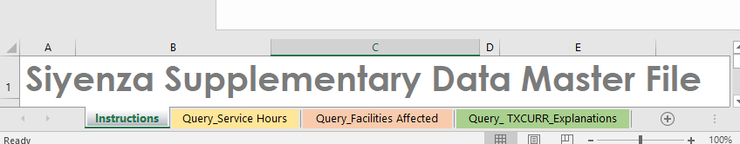
  + *S:\ESI\_DASHBOARDS DATA GUIDANCE_\DATA_SIYENZA*
  + *Data🡪Refresh All: A Query appends #3 and #4 above into 3 individual sheets in one workbook*
    - * *Query_Service Hours:* Double check to make sure all hours are complete for the relevant week. Copy and paste the extended_hours and weekend_hours columns from master sheet into the TAR sheet on both the CDC dataset/dashboard and the Weekly dataset for interagency. Service_hours will automatically populate.
      * *Query_Facilities Affected:* For any new facilities that are affected in the ‘Query_Facility Affected’ sheet,  copy and paste the facility, date, and reasons (from email via partner) into the ‘Affected Siyenza Summary’ sheet.
      * *Query_TXCURR_Explanations:* Review explanations for flagged facilities and follow-up with partner/ loop in M&E team.

**Downloading ‘Reporting Tool_FINALZED’ tools from Dropbox**

1. **Open each partner’s dropbox folder**
   1. Check to make sure no conflicting copies are open
   2. Note that partners are required to have completed submitting data for the day at 10am
   3. You do NOT need to download or refresh the February_Frenzy files
2. **Download and Save here (replacing old one):**
   1. S:\ESI\_DASHBOARDS DATA GUIDANCE_\DATA_SIYENZA\DATA_SIYENZA_PLUS
      1. Do not change the name of the file, and do not create a second version
      2. Make sure no other files are in this folder
      3. Never remove the files from this folder

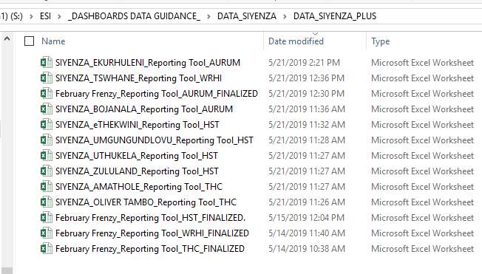

1. **Open each district file, select the ‘Query’ sheet, and REFRESH QUERY**
   1. You do NOT need to download or refresh the February_Frenzy files
   2. Data🡪 Refresh All, then save and close file

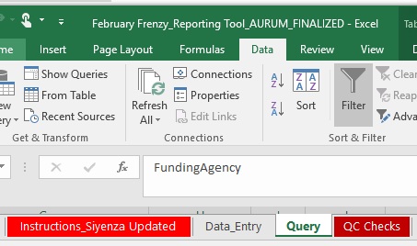

* + 1. ***Partner Reporting Tools Query Steps:*** Make dates long, Make indicators wide, Change the dates to a date format

**Updating the CDC Daily Dashboard**

1. **Open the Dashboard file** 
   1. *S:\ESI\_DASHBOARDS DATA GUIDANCE_\DATA_SIYENZA\DASH_SIYENZA_PLUS*
      1. SA_CDC_SiyenzaPlus_Dashboard_Date

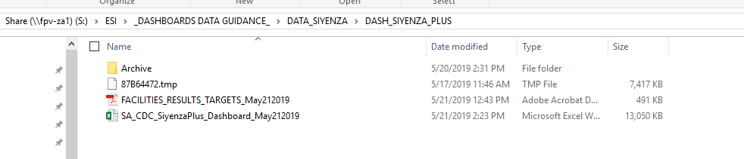

1. **Select the ‘Siyenza’ sheet, and REFRESH QUERY**
   1. Data🡪 Refresh All, then save file

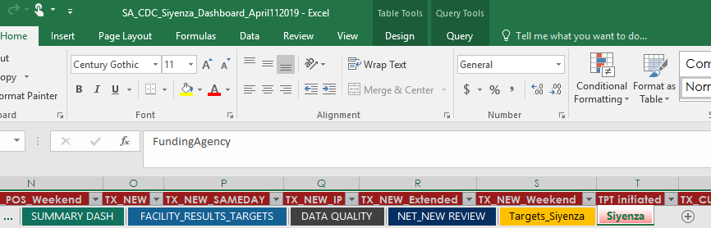

1. **Navigate to the ‘Summary Dash’ sheet**
   1. Data🡪 Refresh All, then save file
2. **Check to make sure recent data is reflected in the Dashboard by checking the Daily values in the HTS_TST_POS/TX_NEW visuals**
3. **Updated all formulas and dates in dashboard (Weekly, Monday’s Only)**
   1. SUMMARY DASH- Update visuals weekly
   2. PIVOTS- Drag down formulas to current week in columns AR to CI
   3. FACILITIES_RESULTS_TARGETS- change all dates
   4. NET NEW REVIEW- update formulas for the most recent TX_CURR Friday
   5. TOP PERFORMER- change all dates
4. **Review Completeness Checks on ‘DATA QUALITY’ sheet**
   1. On Mondays, Focus on TX_CURR values that are +/-3%
   2. Note issues to raise with partners in daily email
   3. If the issues are major - hold off on sending out Dashboard until the data is corrected
   4. If the issues are minor- send out dashboard, and follow-up with partners so issues can be resolved for the following day’s dashboard

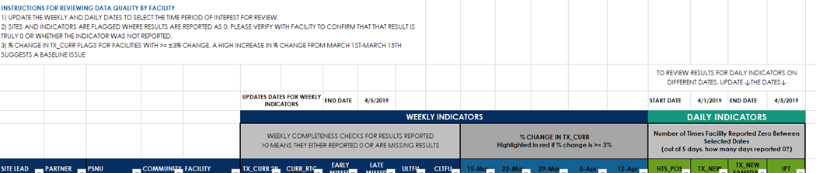

1. **Review ‘NET NEW Review’ Sheet** & **‘Daily Indicator Review’ Sheet** & **‘Weekly Indicator Review’ Sheet**
   1. On Mondays, Focus on TX_CURR values that are +/-3%
   2. Check for outliers
2. Check for outlier values (in PIVOTs or in originally dataset)
3. **At this time, it’s usually time for the 12:30pm partner call- you can pull up the DATA QUALITY tab and review that partner-by- partner (Monday’s Only)**
4. **Update Service Hours (Monday’s Only)**
   1. Copy and paste the extended_hours and weekend_hours columns from ‘Supplementary Siyenza Data File’ into the TAR sheet on both the CDC dataset/dashboard and the Weekly dataset for interagency. Service_hours will automatically populate.
5. Export ‘FACILITIES_RESULTS_TARGETS’ sheet to PDF
6. **Email Dashboard & PDF to all the people on the Following ‘Siyenza Email List_CDC & DOH Dashboard’ (BCC all contacts)**
   1. S:\ESI\_DASHBOARDS DATA GUIDANCE_\DATA_SIYENZA\Data Management\ Email Lists
      1. Note any issues that would affect their review (i.e. missing TX_CURR, data quality checks ongoing)
7. **Email Dashboard and PDF to all partners on the Following ‘Siyenza Email List_Partners Dashboard’**
   1. S:\ESI\_DASHBOARDS DATA GUIDANCE_\DATA_SIYENZA\Data Management\ Email Lists
      1. Remind partners of pending issues that need to be resolved (usually COB unless urgent i.e. day of interagency dataset being sent!)
      2. Note any issues that would affect their review (i.e. missing TX_CURR, data quality checks ongoing)